Indiano Cafe

Department of Computer Science and Application
by
Ankit Khandelwal: 2025bcaaimlankit21684
Anuj Gautam: 2025bcaaimlanuj24409
Hardik Sinha: 2025bcaaimlhardik22493
Himanshi Saxena: 2025bcaaimlhimanshi21139
Varun Bhardwaj: 2025bcacsbvarun22420



Under the Supervision of

Mr. Kapil Gulati

(Designation)

Department of Computer Science and Application
School of FCE
Poornima University, Jaipur
April, 2026

- ABRATCT

The Indiano Cafe project is an intelligent, AI-integrated food ordering and recommendation system that enhances traditional digital cafe platforms by introducing personalized, health-aware decision-making capabilities. The primary objective of the system is to assist users in selecting optimal food combinations based on nutritional balance, user preferences, and potential health conditions.

Unlike conventional food ordering systems that only display menu items, this system uses Artificial Intelligence to analyze user-selected items and generate smart recommendations. The AI model processes the input using a predefined prompt and returns optimized combinations that improve dietary quality and user satisfaction.

Additionally, the system incorporates a health-aware filtering mechanism. Users can optionally specify medical conditions such as diabetes, cholesterol, or general fitness goals. Based on this input, the system dynamically modifies menu suggestions to ensure healthier choices.
The system architecture consists of a frontend interface, backend processing unit, and AI API integration, making it a hybrid model combining web technologies and artificial intelligence.

This project demonstrates the practical application of AI in real-world consumer systems and highlights the potential for intelligent automation in the food and hospitality industry.

TABLE OF CONTENTS

S. No. | Contents | Page No.
1 | TITLE PAGE | 01
2 | ABSTRACT | 02
3 | INDEX | 03
4 | INTRODUCTION | 04
5 | PROJECT OBJECTIVES | 05
6 | PROJECT METHODOLOGY | 06
7 | ARCHITECTURE DIAGRAM | 08
8 | COMPREHENSIVE CODE | 10
9 | CONCLUSION | 12
10 | FUTURE SCOPE | 13

INTRODUCTION

In the modern digital era, food ordering systems have become an essential part of daily life. However, most existing platforms focus only on convenience and speed, lacking intelligent decision-making capabilities. They do not assist users in selecting healthier or more optimized meal combinations.
The Indiano Cafe project aims to bridge this gap by integrating Artificial Intelligence into the food selection process. The system not only allows users to browse and select food items but also provides intelligent suggestions based on their choices.
This project is built on the concept of smart dining, where technology assists users in making better lifestyle decisions. By leveraging AI, the system can:
- Analyse food combinations
- Suggest balanced meals
- Adapt recommendations based on health conditions
The project also introduces an innovative approach by incorporating dynamic menu updates and future-ready features such as video-based menus and personalized recommendations.
From a technical perspective, the system integrates:
- Frontend web technologies for user interaction
- Backend server for logic processing
- AI API for intelligent recommendations
Thus, the project serves as a practical implementation of AI in the domain of food technology and user experience enhancement.

PROJECT OBJECTIVES

The primary objectives of the Indiano Cafe project are:

- To develop an AI-integrated food ordering system
Build a platform that combines traditional menu selection with intelligent recommendation features.

- To provide personalized food suggestions
Use AI to analyze selected items and suggest optimized combinations based on nutrition and balance.

- To introduce health-aware filtering
Allow users to input health conditions and modify recommendations accordingly.

- To enhance user interaction and experience
Create a responsive and dynamic user interface that simplifies food selection.

- To implement real-time AI response generation
Integrate APIs that process user input and return suggestions instantly.

- To design a scalable and modular system architecture
Ensure the system can be extended with additional features in the future.

PROJECT METHODOLOGY

The development of the system follows a structured software development lifecycle:

1. Requirement Analysis
- Identification of user needs such as ease of ordering and healthy suggestions
- Analysis of existing food ordering systems and their limitations
- Defining system requirements including AI integration and dynamic UI

2. Design
- Designing user interface for menu browsing and selection
- Structuring backend logic for data flow
- Defining API communication process
- Creating prompt structure for AI recommendations

3. Development Phase

Frontend Development
- Built using HTML, CSS, and JavaScript
- Provides interactive menu selection
- Displays recommendations dynamically

Backend Development
- Implemented using Node.js
- Handles API requests and responses
- Manages data processing and communication

4. AI Integration
- User-selected items are sent to AI API
- A predefined prompt is used to guide the AI
- AI analyzes combinations and returns optimized suggestions

Example logic:
- Input: Selected food items
- Processing: AI evaluates nutritional balance
- Output: Suggested combinations

5. Testing Phase
- Functional testing of each module
- Validation of AI-generated outputs
- Debugging UI and backend errors
- Ensuring system stability

6. Deployment (Future Plan)
- Hosting on a live server
- Integration with payment gateways
- Performance optimization

ARCHITECTURE AND DIAGRAMS

System Architecture

User → Frontend → Backend → AI API → Backend → Frontend → User

Component Description

1. User Interface (Frontend)
- Displays menu items
- Accepts user input
- Shows AI recommendations

2. Backend Server
- Receives user selections
- Processes requests
- Sends data to AI API

3. AI API
- Analyzes selected items
- Generates optimized suggestions
- Returns response

4. Response System
- Displays recommendations
- Updates UI dynamically

Working Flow

Frontend (Website UI)
↓
User selects food items
↓
Backend Server (Node.js)
↓
AI API Call (based on selected items only)
↓
AI Model Processing
↓
Response Returned to Backend
↓
Frontend Displays Recommendations
↓
Checkout + Payment API
↓
Database stores order

COMPREHENSIVE CODE (OVERVIEW)

Frontend Code Responsibilities
- User interaction handling
- Menu selection system
- Display of recommendations

Backend Code Responsibilities
- API request handling
- Data processing
- Integration with AI services

AI Prompt Logic

prompt = "Suggest the best healthy food combinations from the selected items considering balanced nutrition and user preferences."

A. Key Code Snippets:

1. Data base logic:

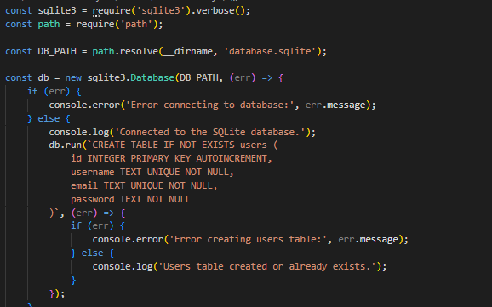

2. Chatbot logic

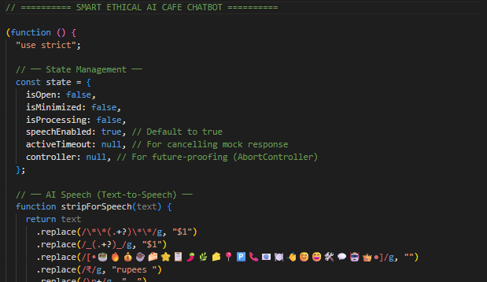

B. UI Screenshots:

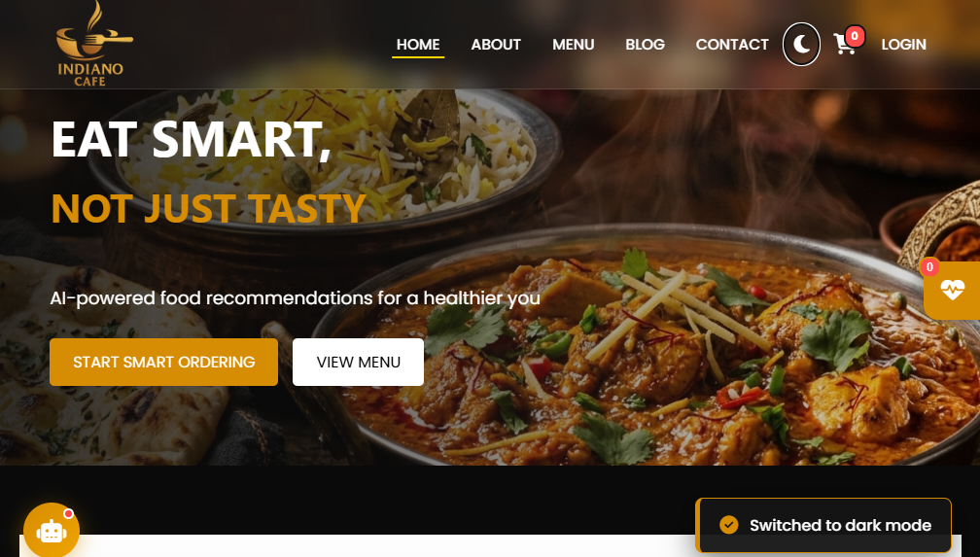

Key Functionalities
- Dynamic input processing
- Real-time recommendation display
- Scalable backend design
- Modular architecture

CONCLUSION

The Indiano Cafe project successfully demonstrates the integration of Artificial Intelligence into a real-world application. It transforms a simple food ordering system into an intelligent platform capable of assisting users in making better dietary decisions.
The system achieves:
- Enhanced user experience
- Smart recommendation generation
- Health-aware decision support
This project highlights the potential of AI in everyday applications and opens new opportunities in the food and hospitality industry.

FUTURE SCOPE
The project has significant potential for future expansion:

- Payment Integration
Integration with secure payment systems like Razorpay

- Advanced AI Models
Use of more sophisticated ML/DL models for better accuracy

- User Personalization
Creating user profiles for customized recommendations

- Mobile Application Development
Expanding system to Android and iOS platforms

- Voice-Based Ordering System
Integration with voice assistants

- Nutrition Tracking System
Display calories and nutritional values

- Wearable Integration
Sync with fitness devices for real-time health data

- Video-Based Menu System
Replace static images with interactive videos

